**1.Create a simple cloud software application and provide it as a service using any Cloud Service Provider to demonstrate Software as a Service (SaaS).**

**Aim:**

To create a simple cloud software application and provide it as a service using any cloud service provider to demonstrate software as a service (saas).

**PROCEDURE:**

**STEP1:** GOTO ZOHO.COM

**STEP 2:** LOGIN TO THE ZOHO.COM

**STEP 3:** SELECT ONE APPLICATION

**STEP 4:** ENTER APPLICATION NAME

**STEP 5:** CREATED NEW APPLICATION

**STEP 6:** SELECT ONE FORM

**STEP 7:** THE SOFTWARE HASE BEEN CREATED.

**1.Patient Registration Form:**

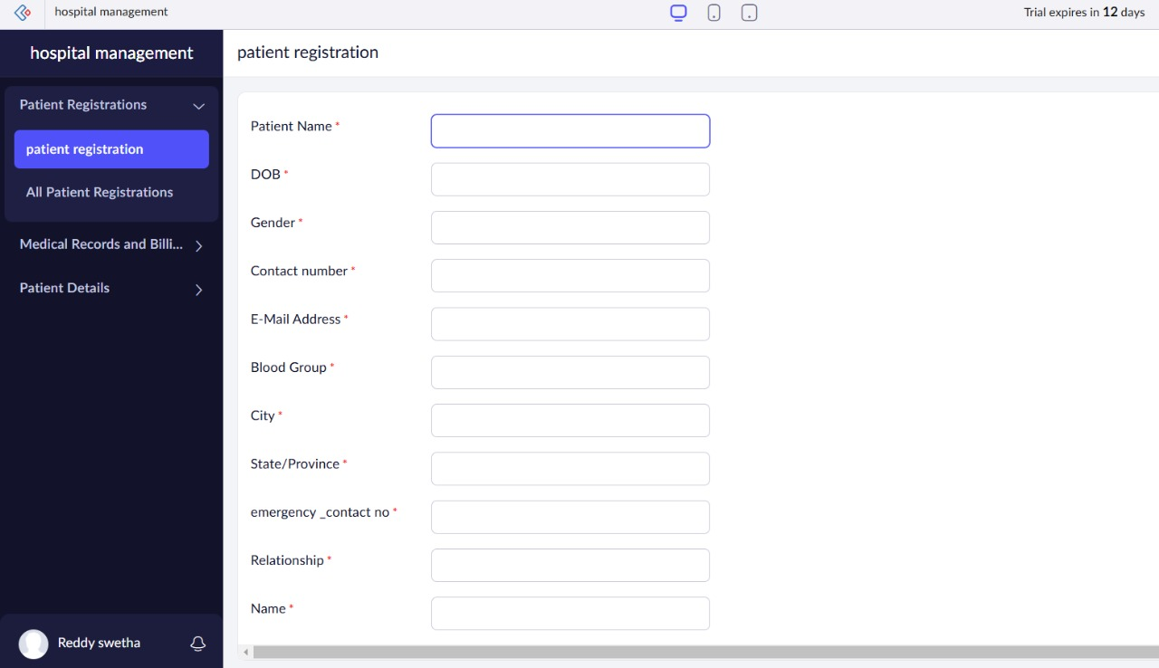

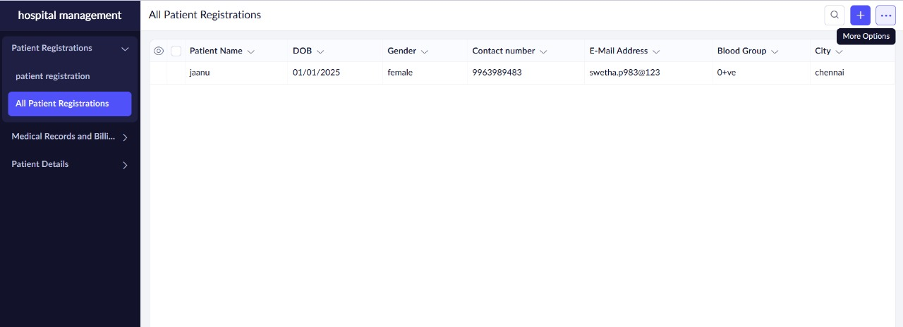

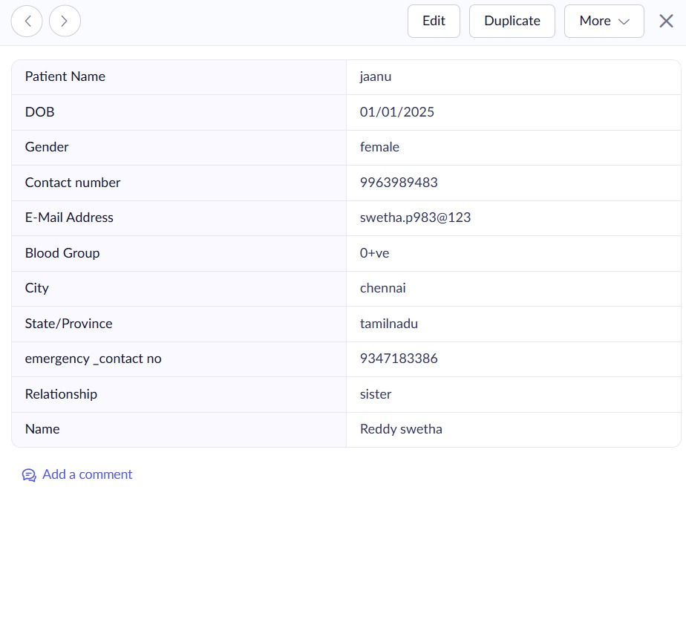

**2. Medical Records and Billing:**

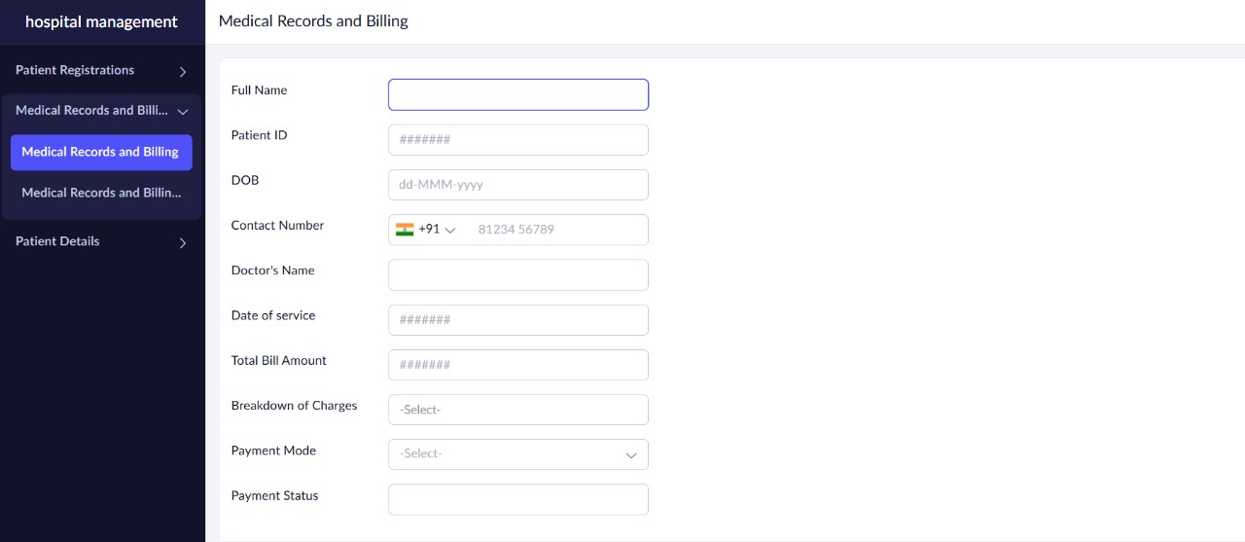

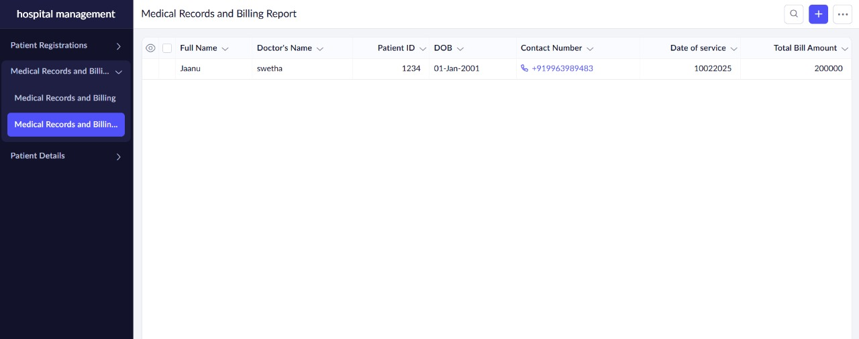

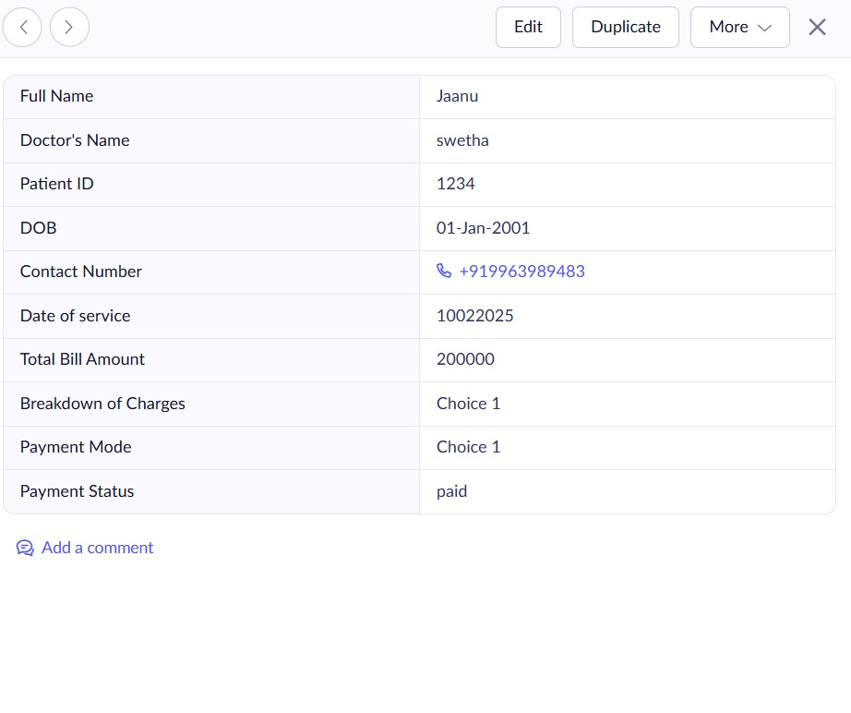

**3.Patient Details:**

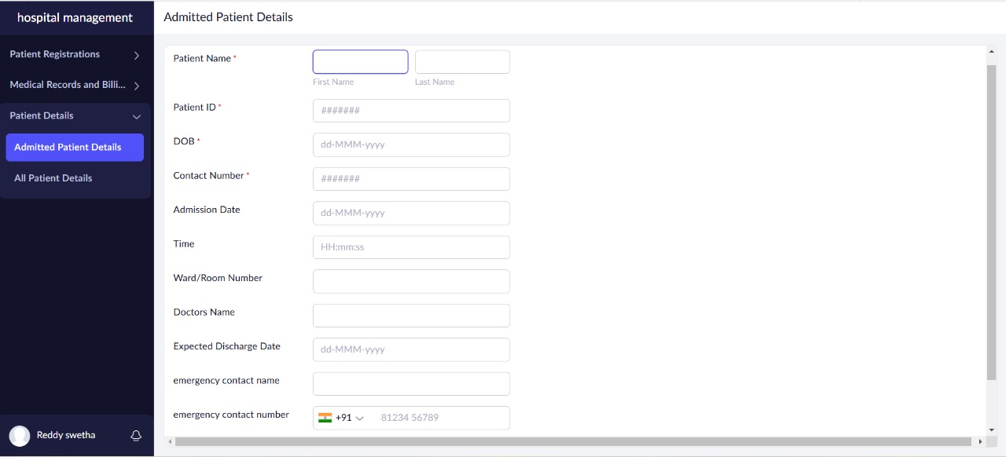

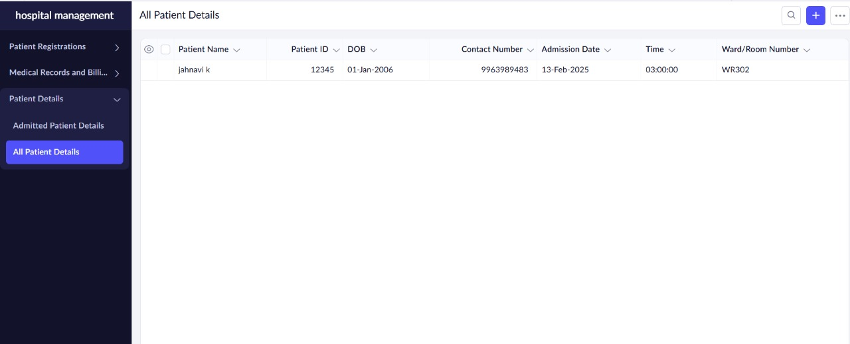

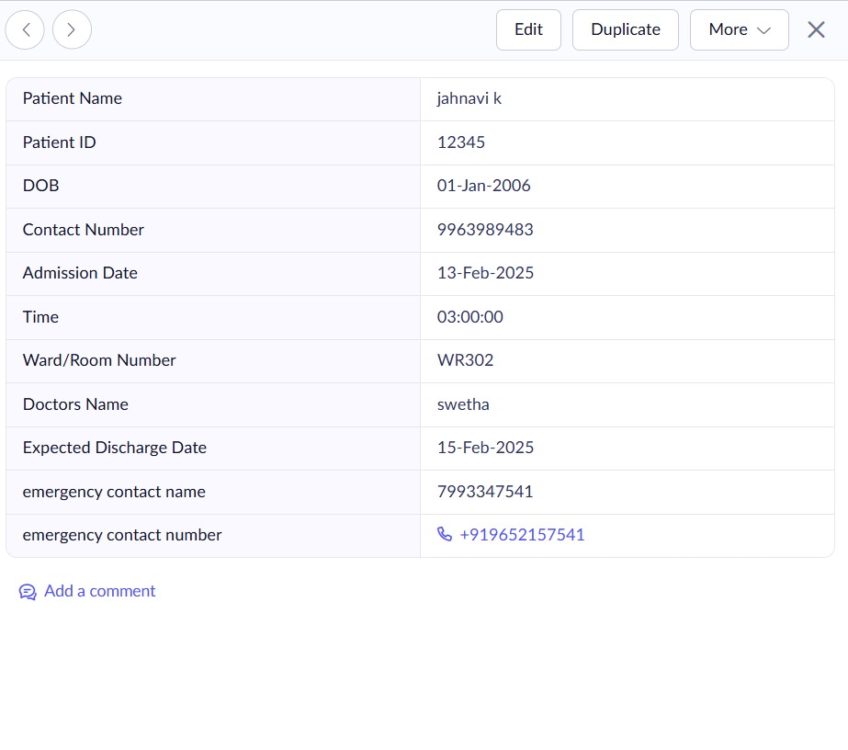

**Result:**

Asimple cloud software application is successfully created.

**EXP NO 2: CREATE A SIMPLE CLOUD SOFTWARE APPLICATION FOR FLIGHT RESERVATION SYSTEM USING ANY CLOUD SERVICE PROVIDER TO DEMONSTRATE SAAS**.

**AIM:**

To create a simple cloud software application for flight reservation system using any cloud service provider to demonstrate saas.

**PROCEDURE:**

**step1:** Go to zoho.com.

**step 2:** Log into the zoho.com.

**step 3:** Select one application step.

**step4:** Enter application name as flight reservation system.

**step 5:** Created new application flight reservation system.

**step 6:** Select one form

**step 7:** The software has been created

**1.Flight Reservation:**

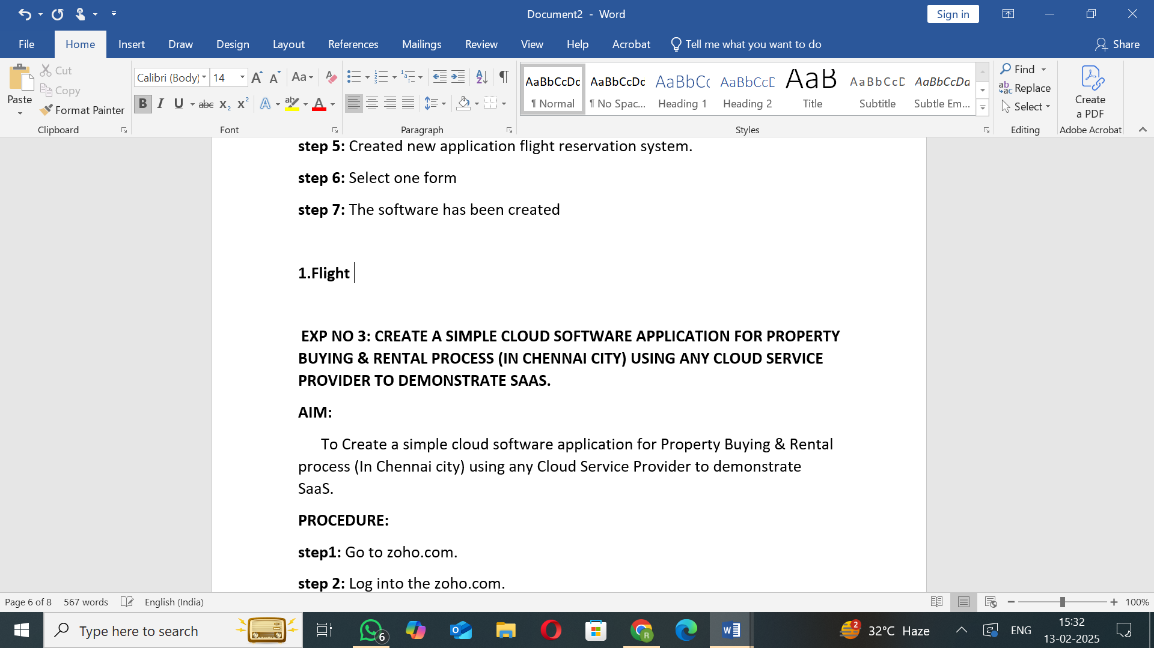

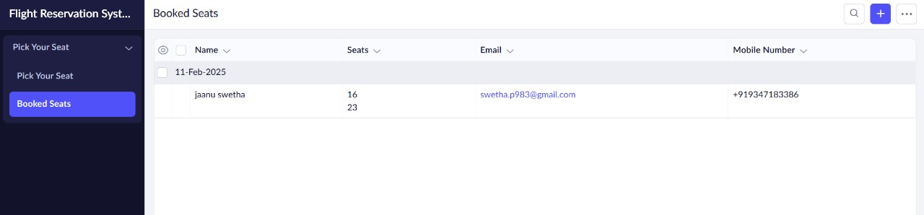

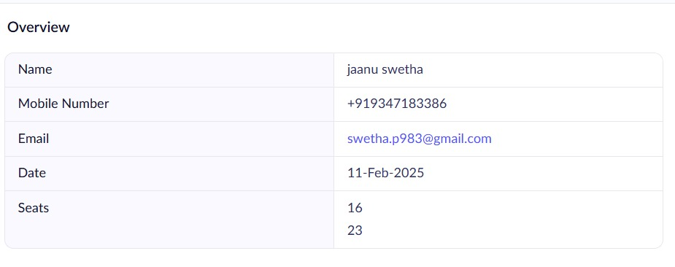

**2.Payment and Billing:**

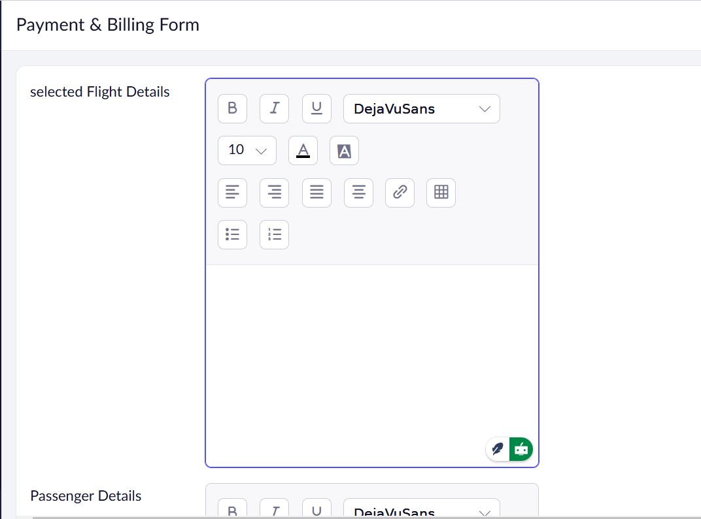

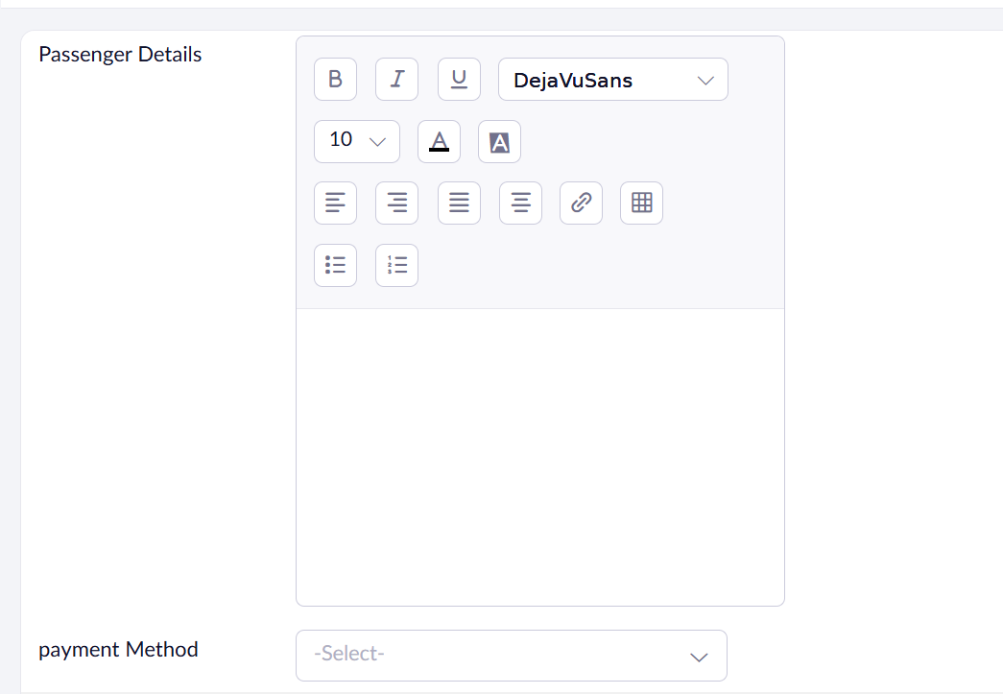

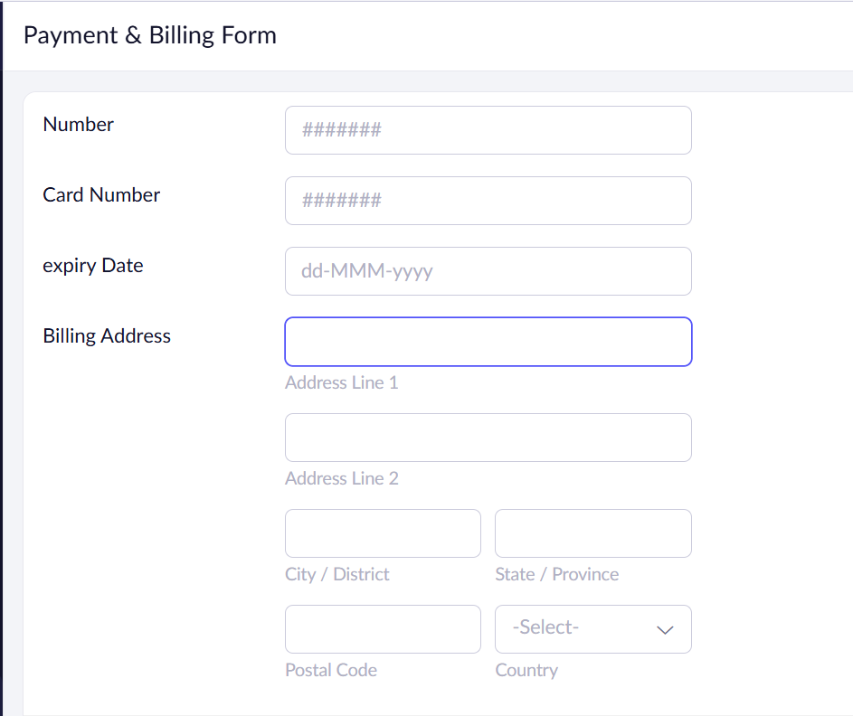

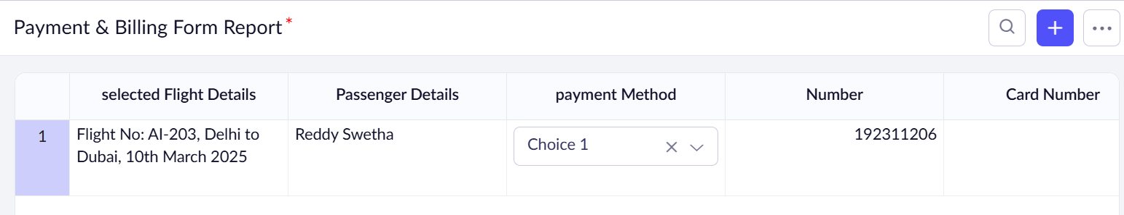

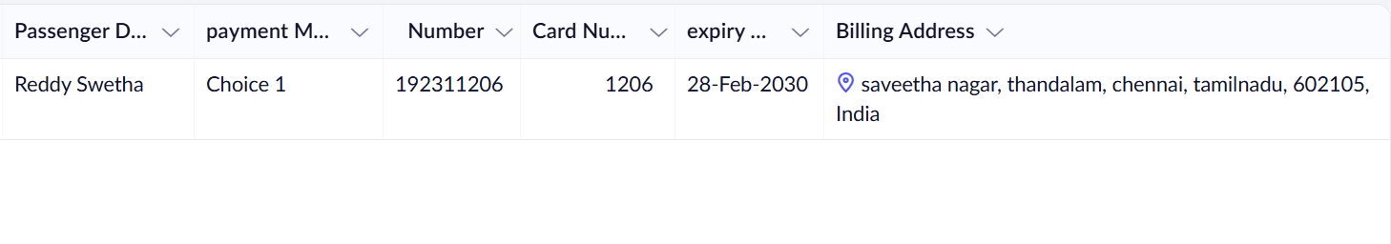

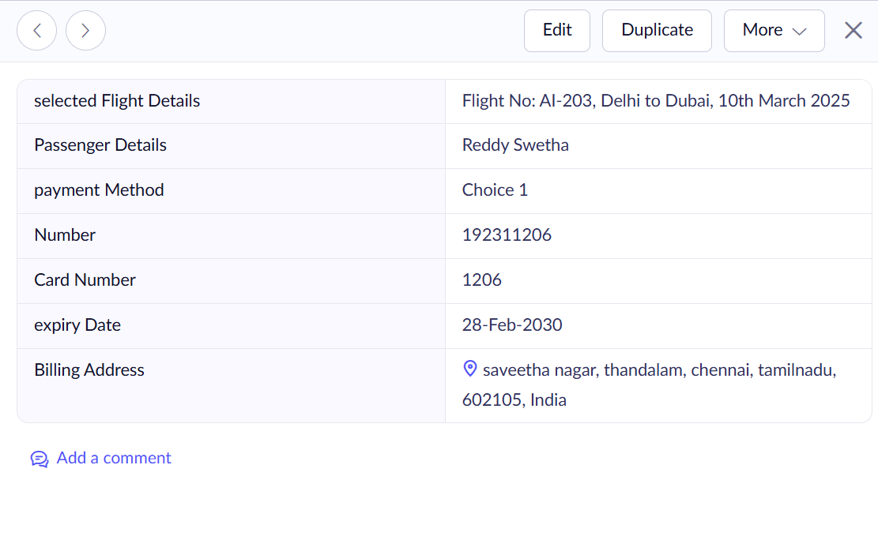

**3.light Cancellation:**

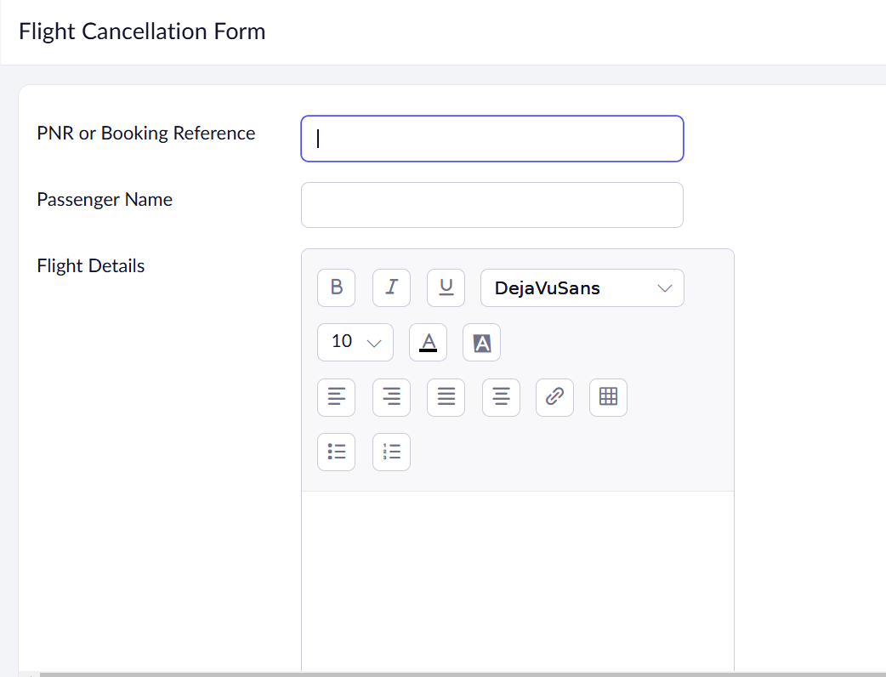

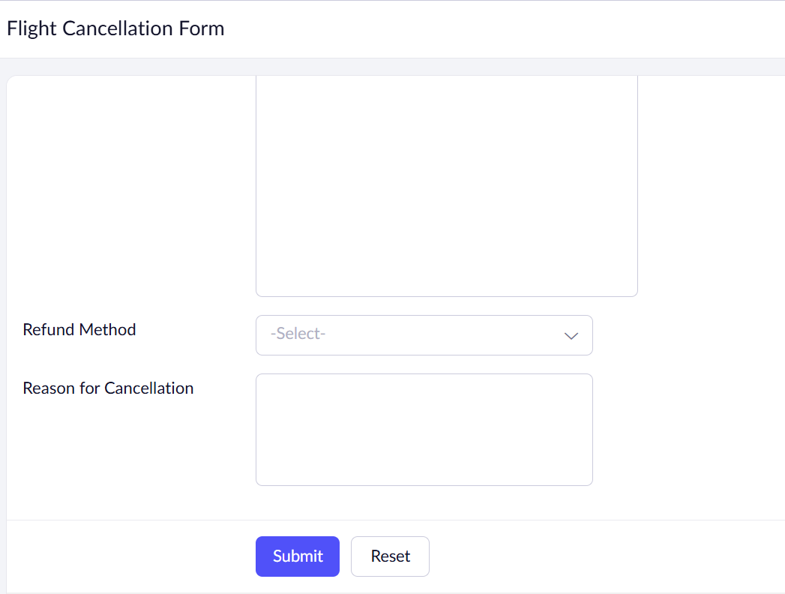

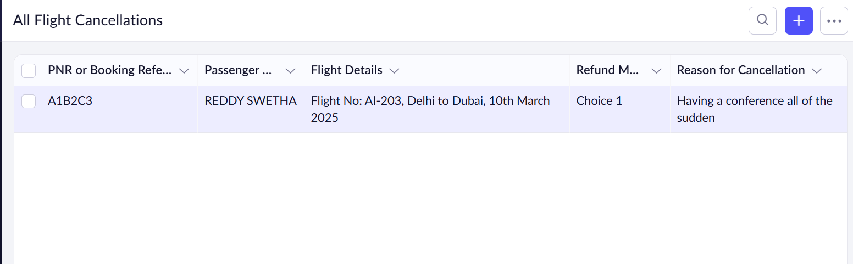

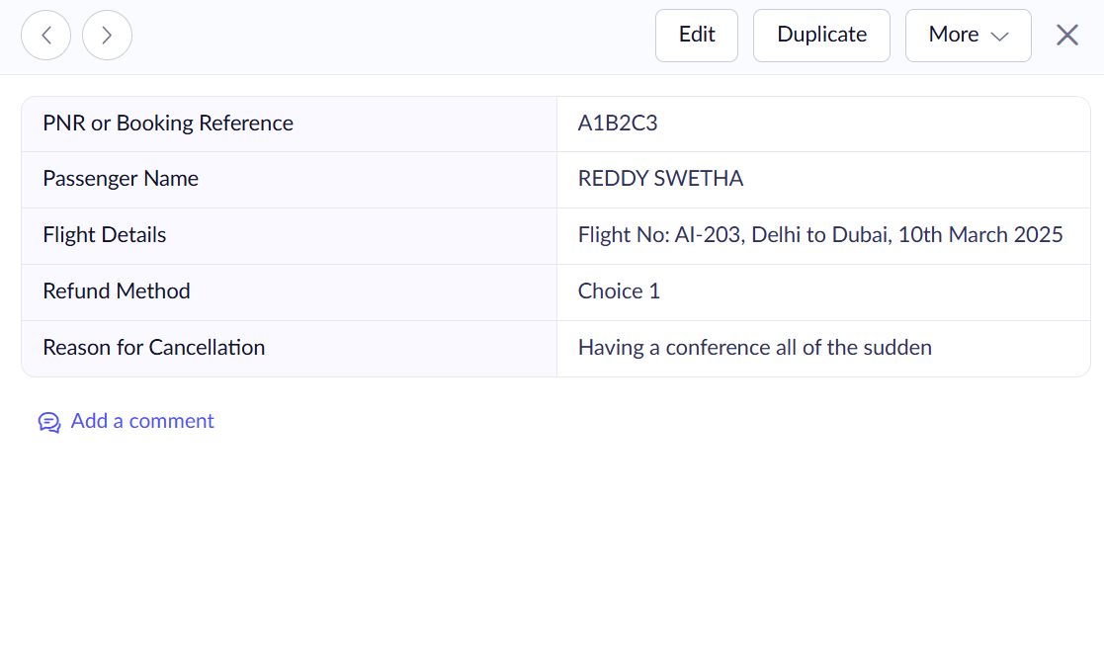

**Result:**

Asimple cloud software application is successfully created.

**EXP NO 3: CREATE A SIMPLE CLOUD SOFTWARE APPLICATION FOR PROPERTY BUYING & RENTAL PROCESS (IN CHENNAI CITY) USING ANY CLOUD SERVICE PROVIDER TO DEMONSTRATE SAAS.**

**AIM:**

To Create a simple cloud software application for Property Buying & Rental process (In Chennai city) using any Cloud Service Provider to demonstrate SaaS.

**PROCEDURE:**

**step1:** Go to zoho.com.

**step 2:** Log into the zoho.com.

**step 3:** Select one application step.

**step4:** Enter application name as property buying & rental.

**step 5:** Created new application as property buying & rental.

**step 6:** Select one form

**step 7:** The software has been created.

**1.Rental Form:**

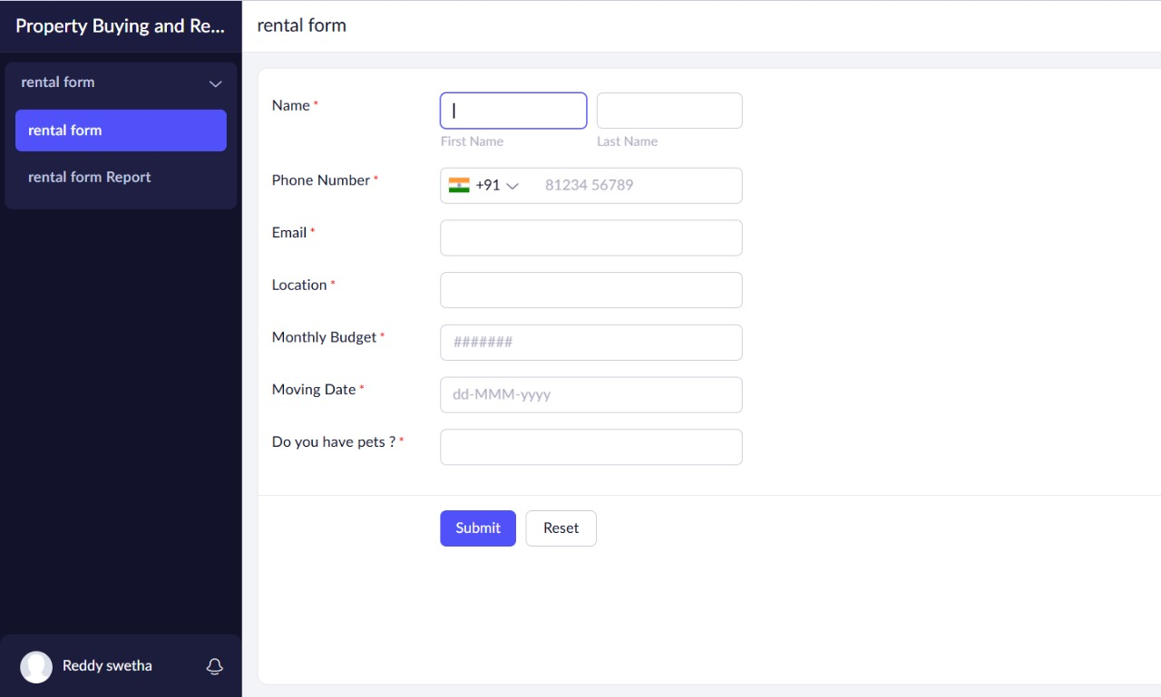

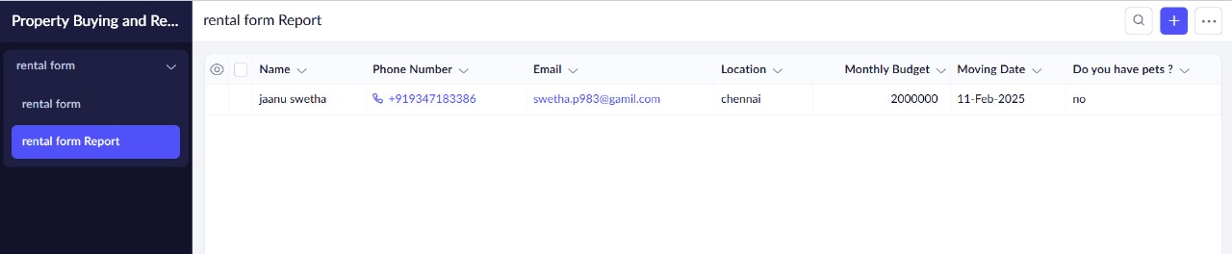

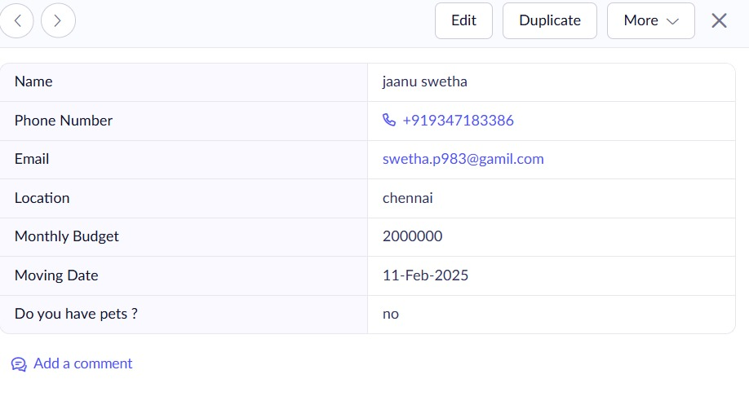

**2.Property Search Form:**

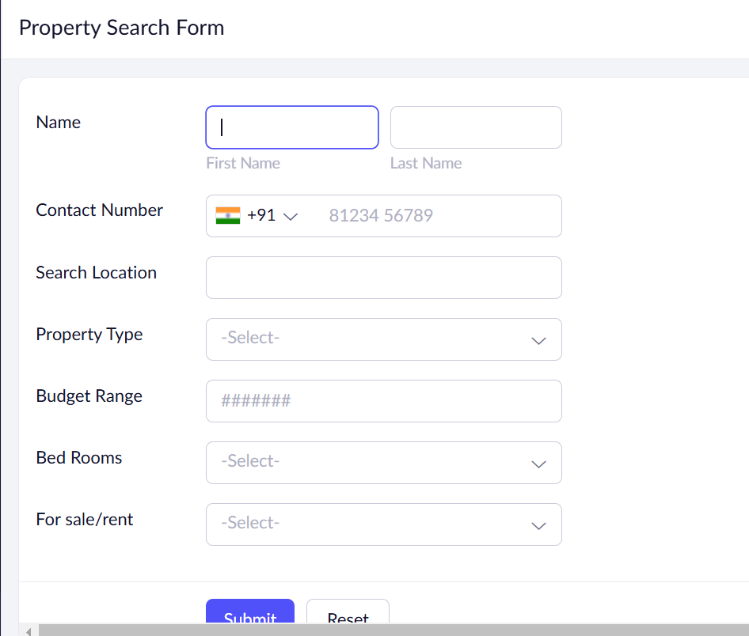

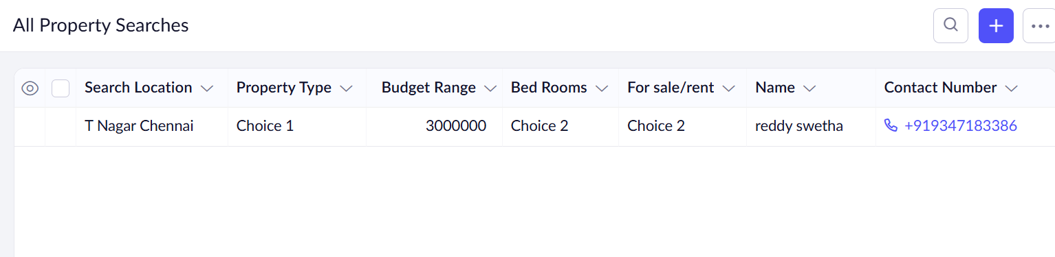

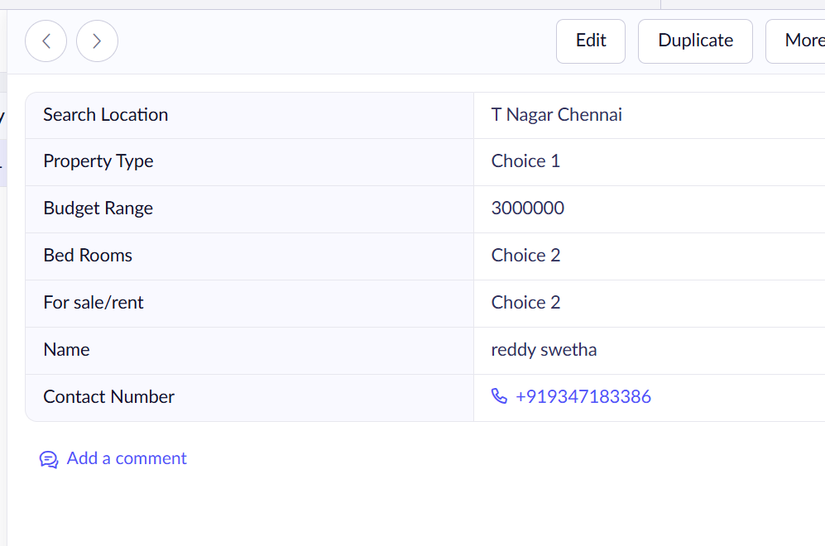

**3.Booking and Payment Form:**

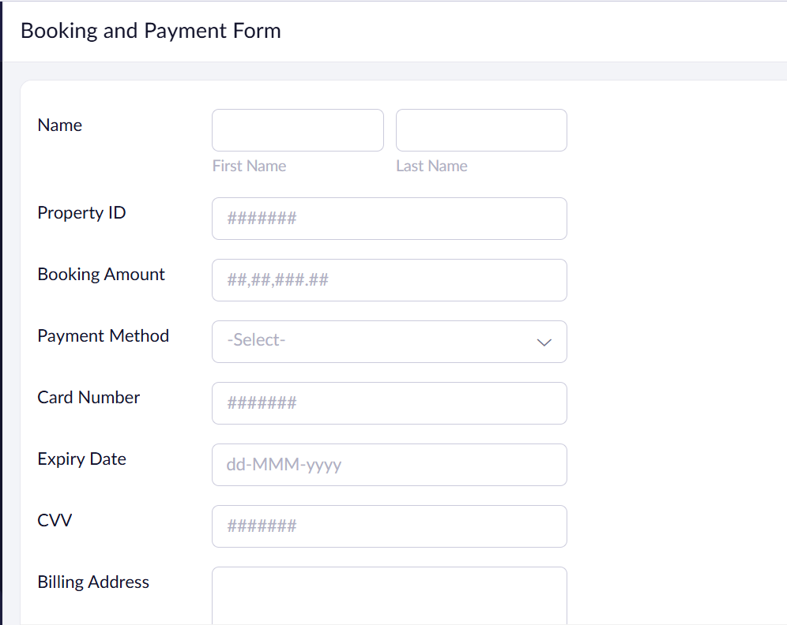

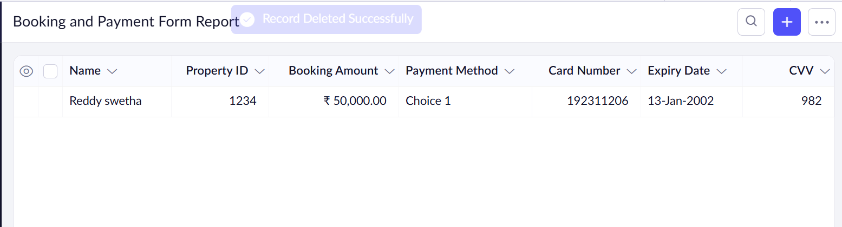

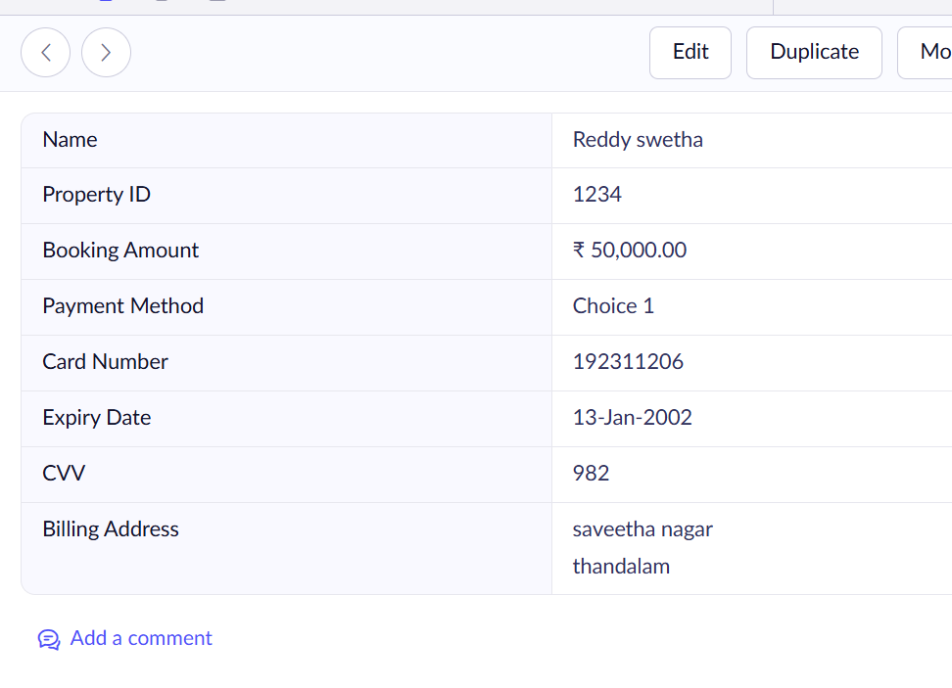

**Result:**

Asimple cloud software application is successfully created.

**EXP NO 4: CREATE A SIMPLE CLOUD SOFTWARE APPLICATION FOR CAR BOOKING RESERVATION SYSTEM USING ANY CLOUD SERVICE PROVIDER TO DEMONSTRATE SAAS.**

**AIM:**

To Create a simple cloud software application for Car Booking Reservation System using any Cloud Service Provider to demonstrate SaaS.

**PROCEDURE:**

**step1:** Go to zoho.com.

**step 2:** Log into the zoho.com.

**step 3:** Select one application step.

**step 4:** Enter application name as Car Booking Reservation System.

**step 5:** Created new application as Car Booking Reservation System.

**step 6:** Select one form.

**step 7:** The software has been created.

**1.Cab Booking Form:**

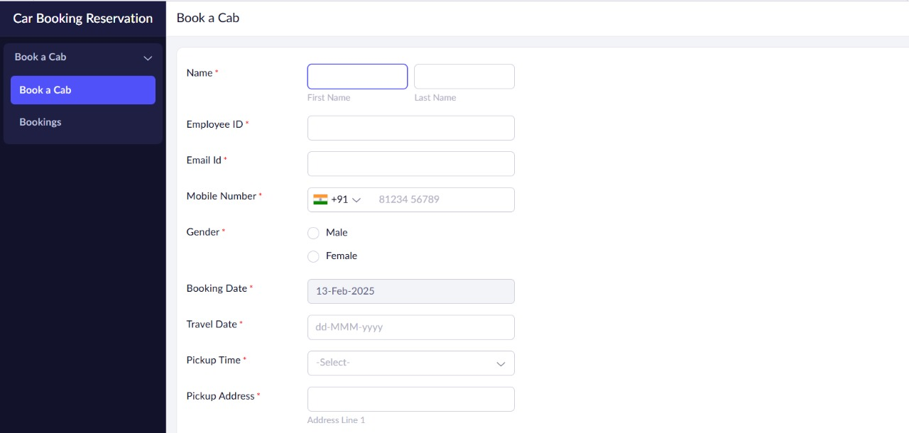

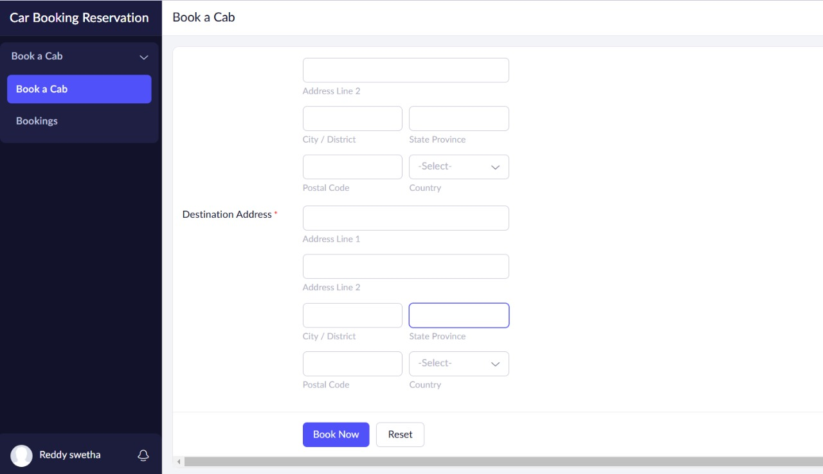

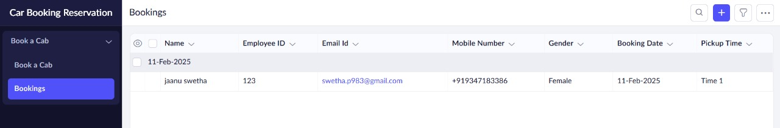

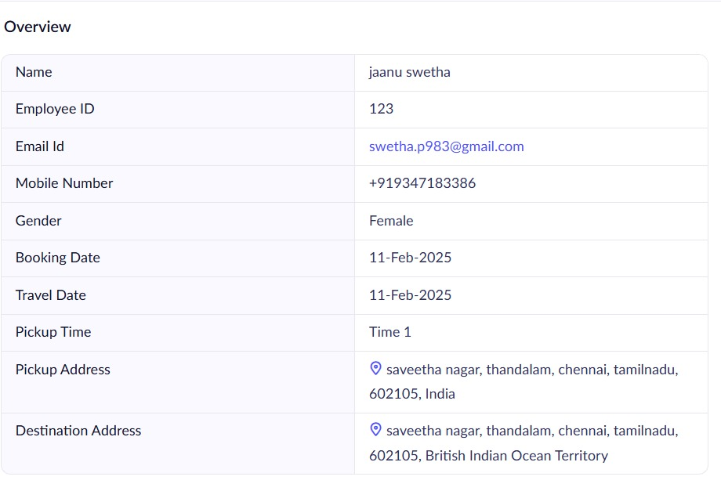

**2.Car Listing Form:**

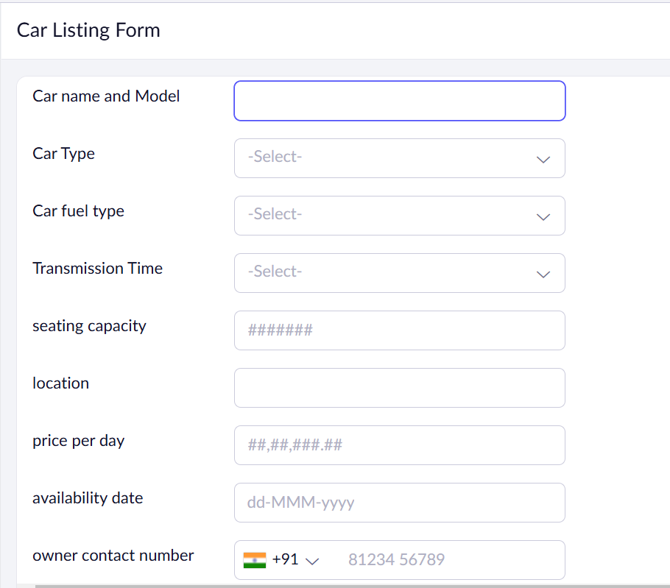

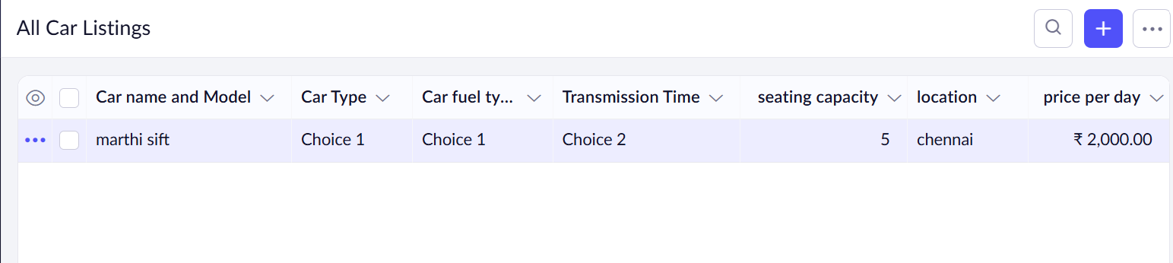

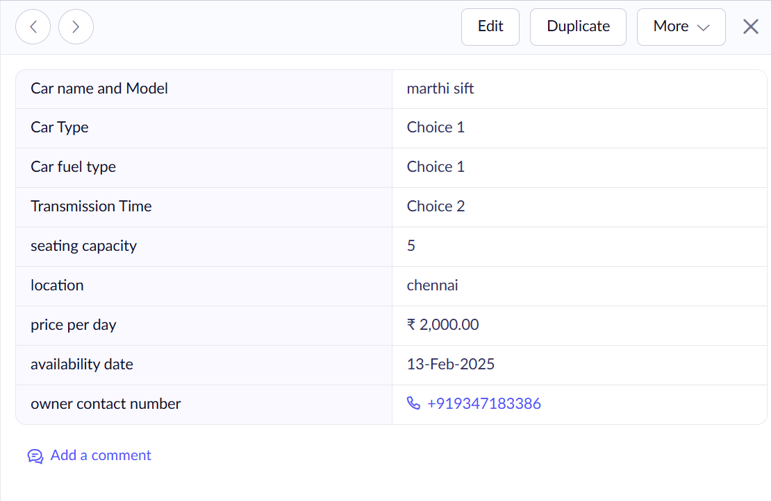

**3.Cancellation and Refund Form:**

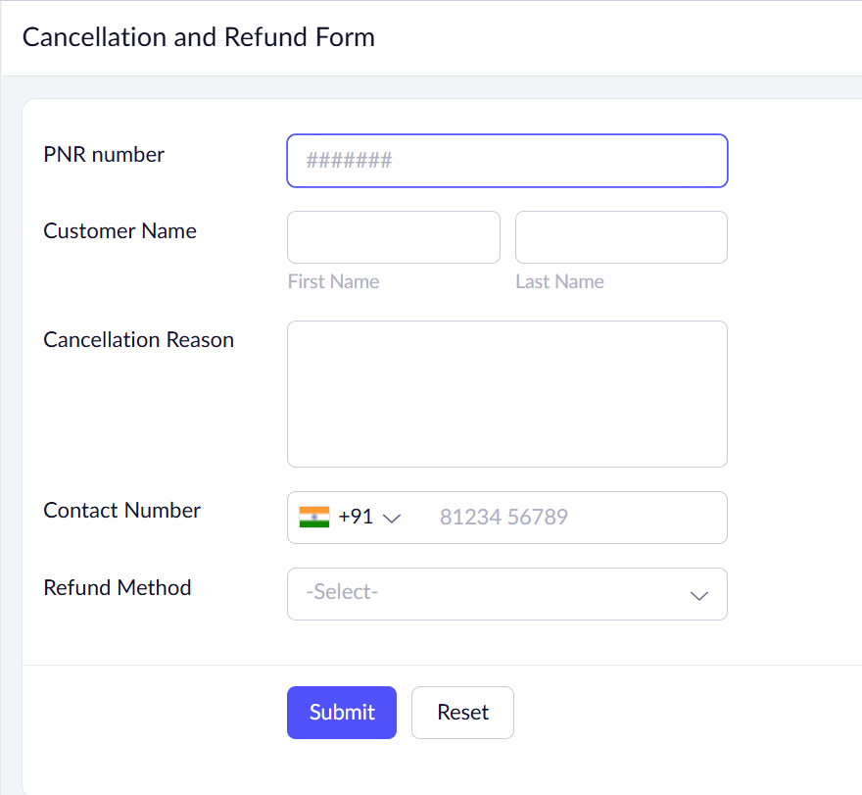

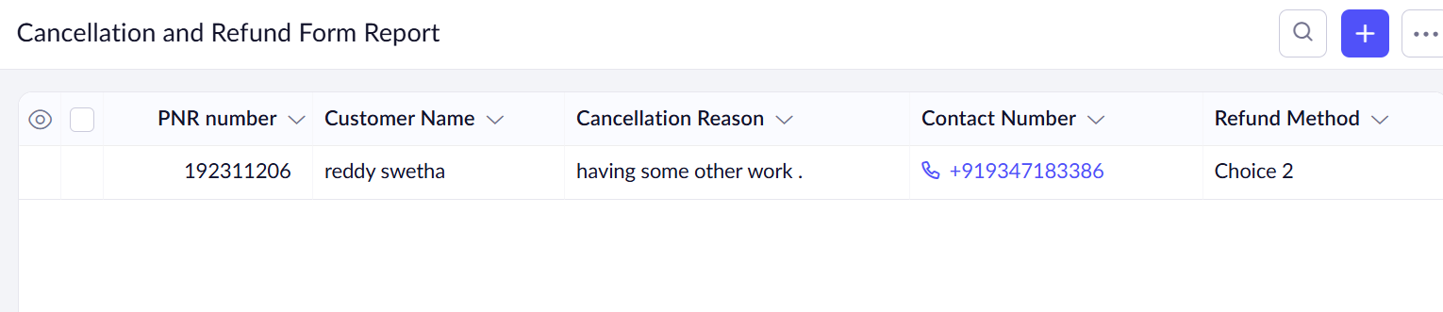

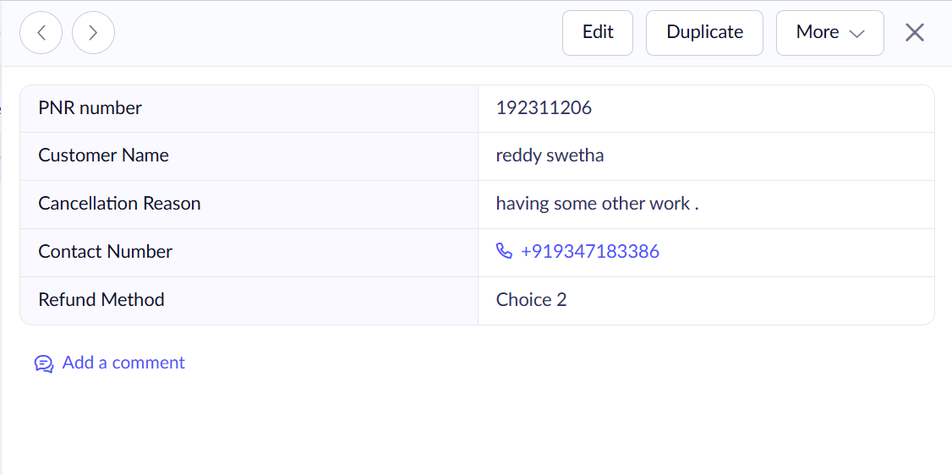

**Result:**

Asimple cloud software application is successfully created.

**EXP NO 5: CREATE A SIMPLE CLOUD SOFTWARE APPLICATION FOR LIBRARY BOOK RESERVATION SYSTEM FOR SIMATS LIBRARY USING ANY CLOUD SERVICE PROVIDER TO DEMONSTRATE SAAS**

**AIM:**

To Create a simple cloud software application for Library book reservation system for SIMATS library using any Cloud Service Provider to demonstrate SaaS

**PROCEDURE:**

**step1:** Go to zoho.com.

**step 2:** Log into the zoho.com.

**step 3:** Select one application step.

**step 4:** Enter application name as library book reservation system.

**step 5:** Created new application as library book reservation system.

**step 6:** Select one form.

**step 7:** The software has been created.

**1.Library Book Reservation:**

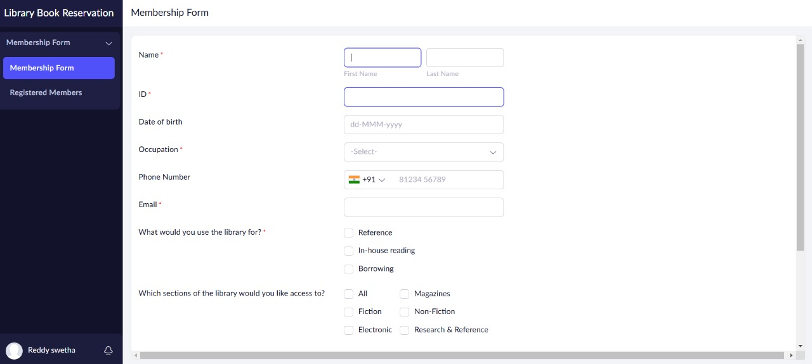

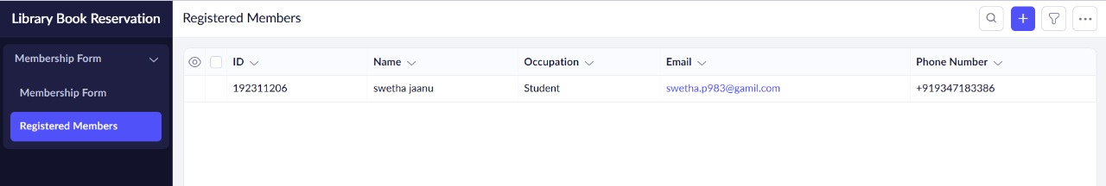

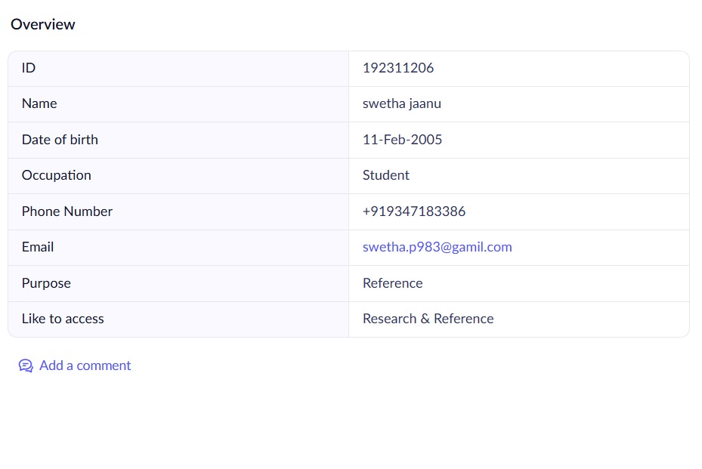

**2.Book Listing Form:**

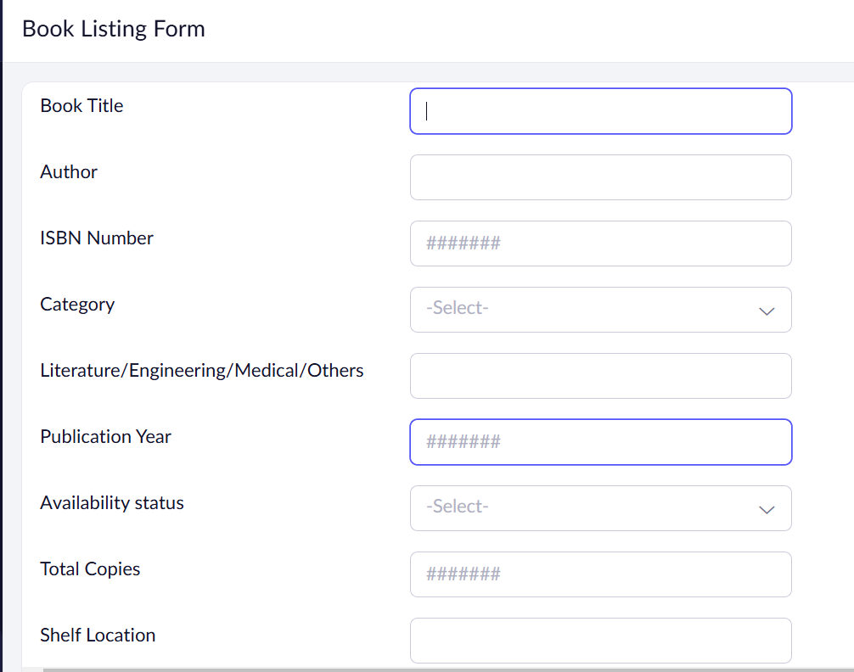

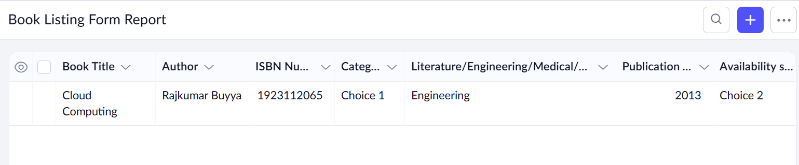

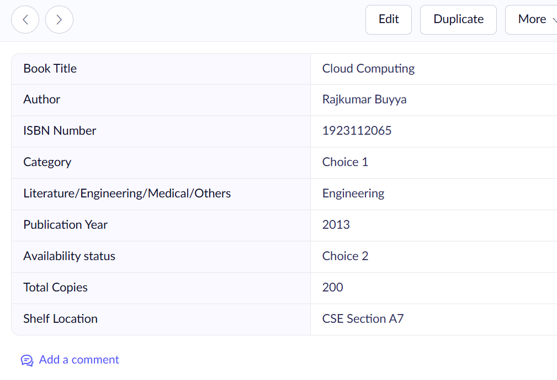

**3.Issue and Return Form:**

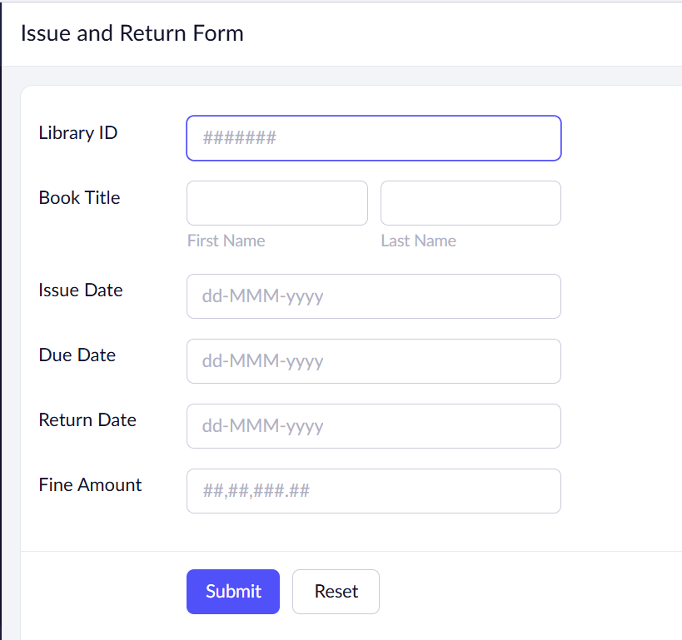

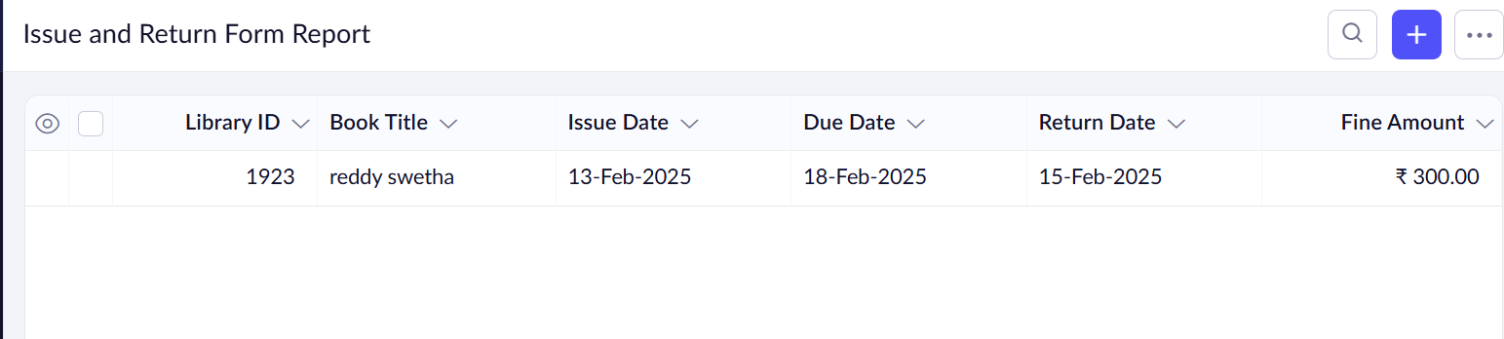

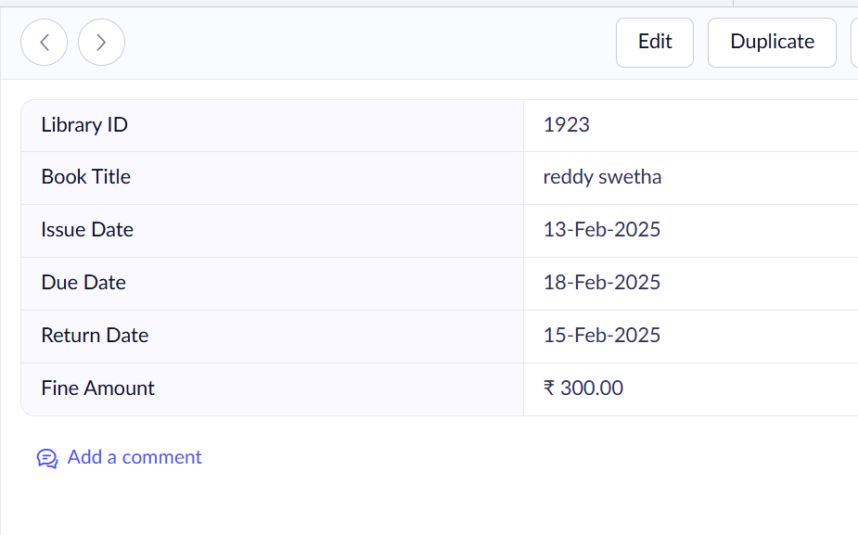

**Result:**

Asimple cloud software application is successfully created.

**EXP NO 6: CREATE A SIMPLE CLOUD SOFTWARE APPLICATION FOR PRODUCT SELLING USING ANY CLOUD SERVICE PROVIDER TO DEMONSTRATE SAAS.**

**AIM:**

To create a simple cloud software application for product selling using any cloud service provider to demonstrate saas.

**PROCEDURE:**

**step1:** Go to zoho.com.

**step 2:** Log into the zoho.com.

**step 3:** Select one application step.

**step 4:** Enter application name as product selling.

**step 5:** Created new application as product selling.

**step 6:** Select one form .

**step 7:** The software has been created.

**1.Review Form:**

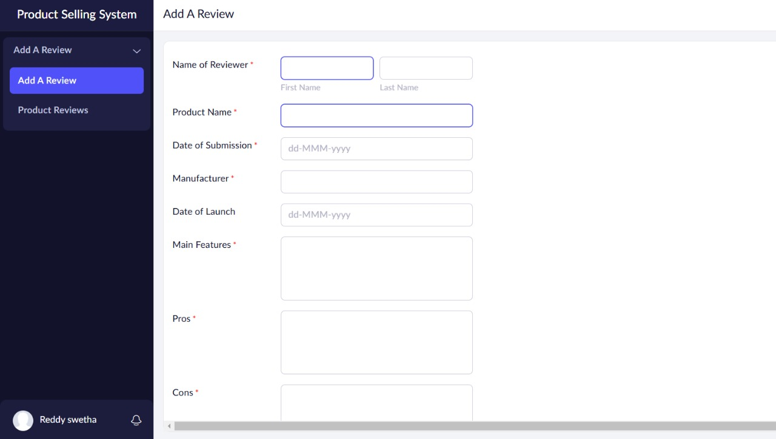

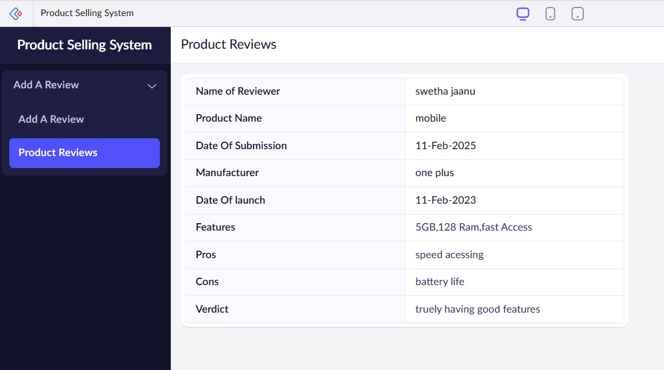

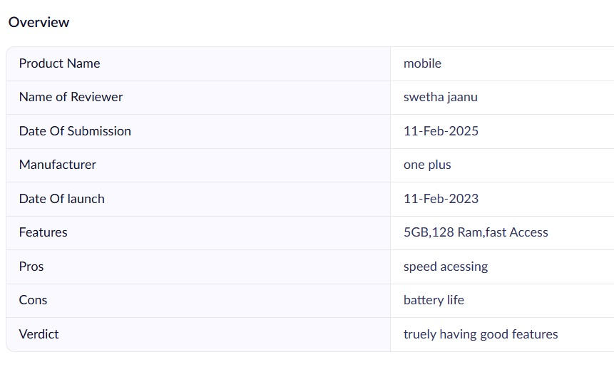

**2.Add to Cart Form:**

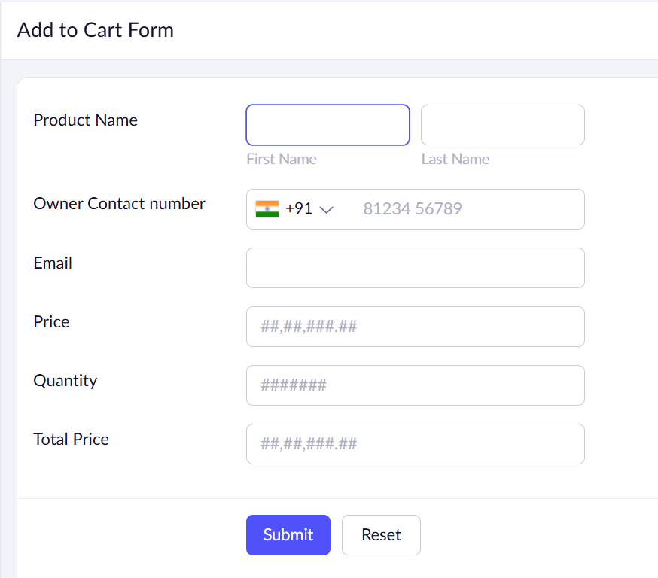

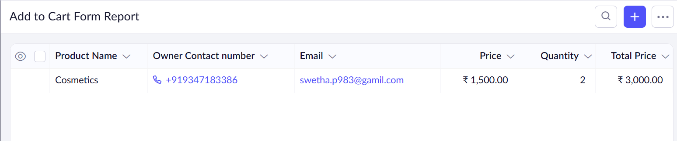

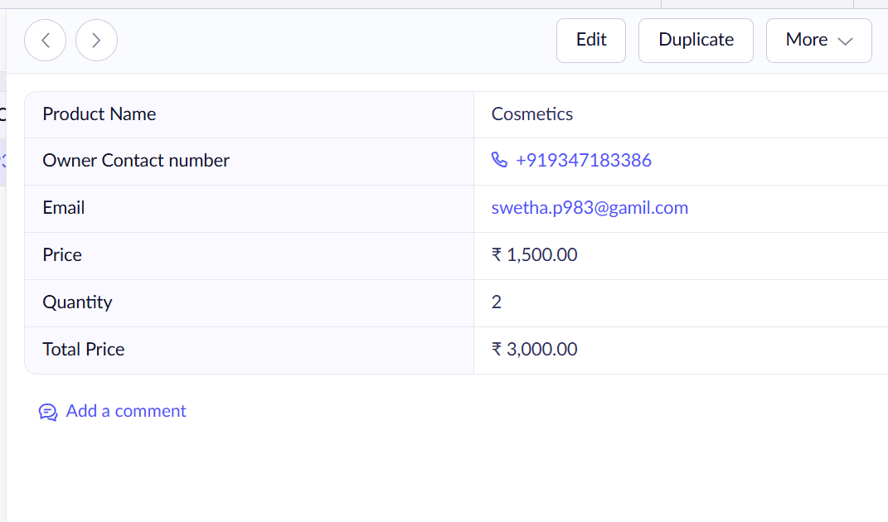

**3.Order Checkout Form:**

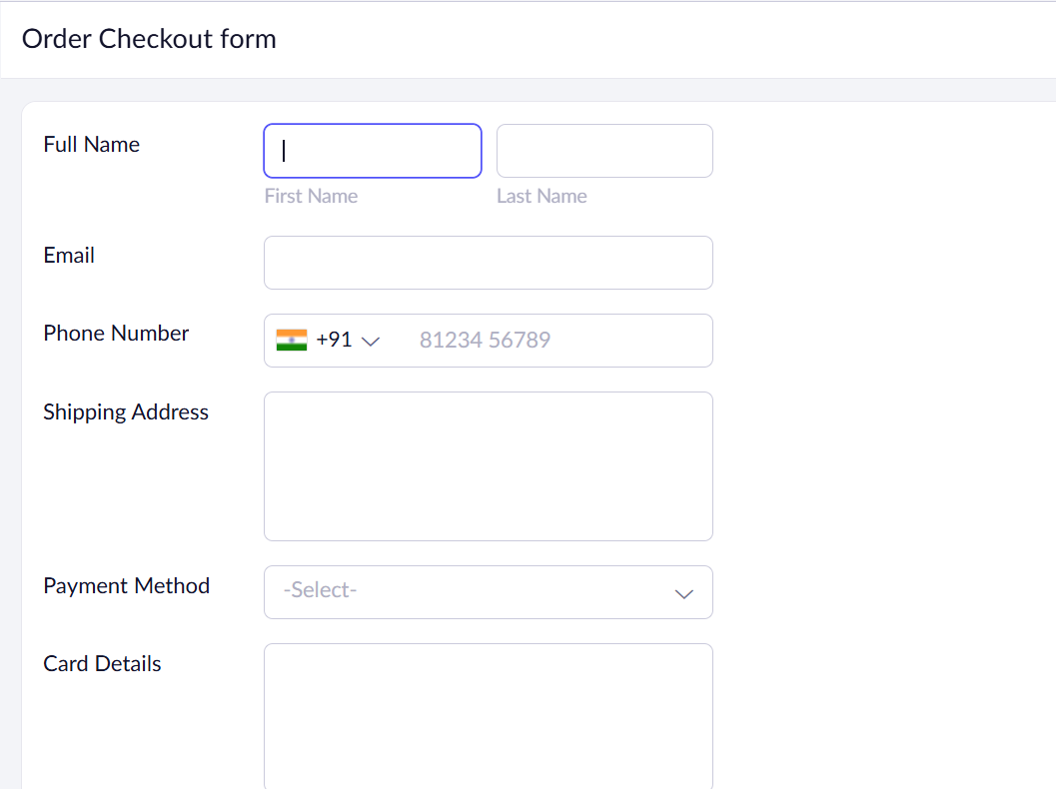

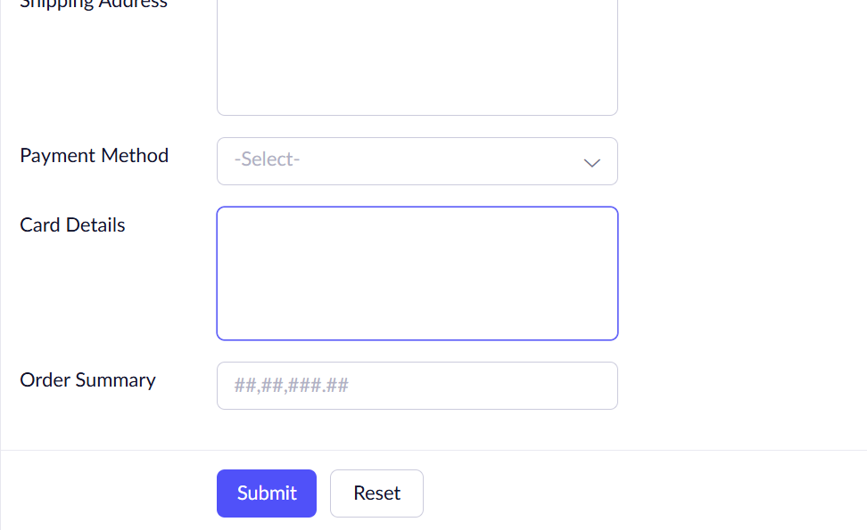

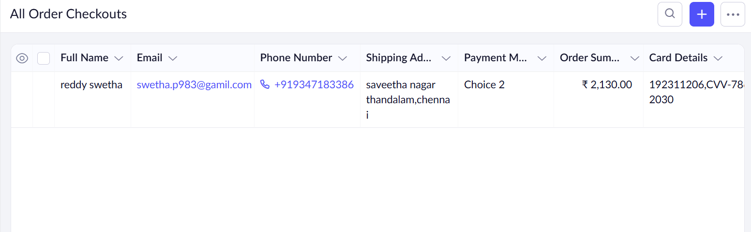

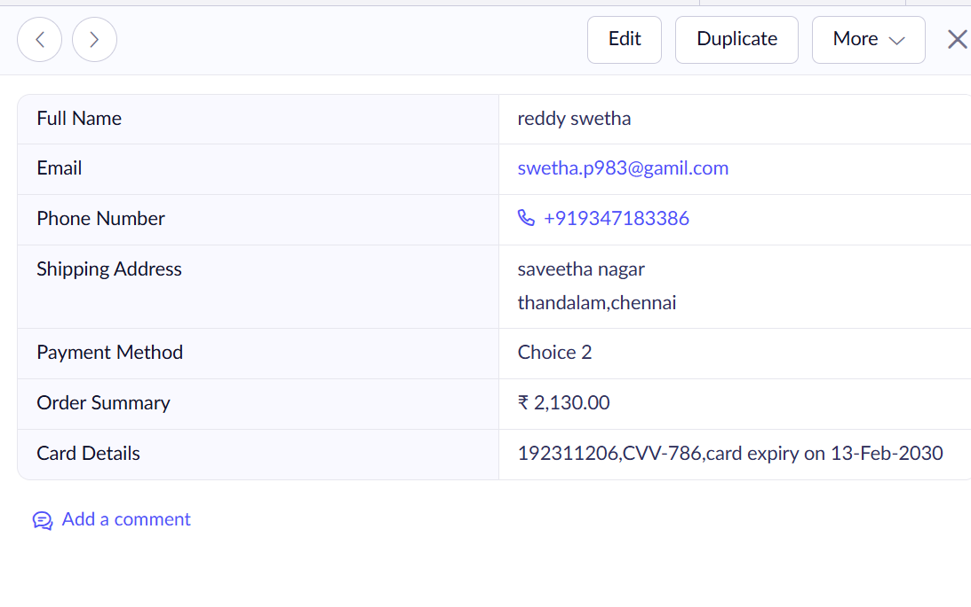

**Result:**

Asimple cloud software application is successfully created.